**E-COMMERCE PERFORMANCE TESTING PROJECT**

As part of a project, a Solutions Architect urgently needs testing completed for an e-commerce website prior to code release. On short notice, he has requested you to create a performance test for the same. Create the following script for RS Components’ Irish Website. The script should test the following pages, part of any standard user journey on the website:

**Homepage > Category Page 1 > Category Page 2 > Category Page 3 > Product Page > Basket Page**

You are also required to parameterise the Category Pages to make sure you test uses random data. Further details around parameterisation is available on the last page of this document.

You are expected to create this test in JMeter. Once complete, please share your JMeter test plan (.jmx file) and results (.jtl file) with us through GitHub. Please do this by sharing the GitHub Repository link with us.

**Please see below for further details around requirements and expected outcomes of this exercise.**

|  |  |
| --- | --- |
| **No. of Scripts** | 1 |
| **Tool** | JMeter |
| **Total Test Duration** | 10 Minutes |
| **Test Type** | RAMP Test |
| **No. of Stages** | 5 Stages |
| **Duration per Ramp Stage** | 2 Minutes per Stage |
| **Peak Throughput Per Second (TPS)** | 1.5 TPS (Peak, Ramp Stage 5) |
| **Additional Capabilities** | Listeners:   * Response Time * Transactions Per Second * Summary Report * Results Tree |
| **Delivery Medium** | GitHub |
| **Deliverables** | * 1 JMeter Test Plan (.jmx) * 1 Results File (.jtl) * Screenshots of TPS and Response Time graphs and Summary Report from JMeter |

**The User Journey should be the following:**

|  |  |  |
| --- | --- | --- |
| **Step #** | **Page/Action** | **URL** |
| **1** | **HOMEPAGE** | *https://ie.rs-online.com/web/* |
| **2** | **CATEGORY PAGE 1** | *https://ie.rs-online.com/web/c/batteries-chargers/* |
| **3** | **CATEGORY PAGE 2** | *https://ie.rs-online.com/web/c/batteries-chargers/battery-charger-accessories/* |
| **4** | **CATEGORY PAGE 3** | *https://ie.rs-online.com/web/c/batteries-chargers/battery-charger-accessories/battery-charger-leads/* |
| **5** | **VIEW PRODUCT** | *https://ie.rs-online.com/web/p/battery-charger-leads/7918270* |
| **6** | **ADD PRODUCT TO BASKET** | *Add product to basket from the product page* |
| **7** | **VIEW BASKET** | *https://ie.rs-online.com/web/ca/basketsummary/* |

**Here are some more details around the user journey, outlining exactly what is required in this test:**

1. Go to **Homepage**
2. Access **Category Page 1** by clicking on **‘Browse**’ and picking one of the categories following the flow shown below. As you can see in the URL above, ‘**batteries-chargers**’ is one such category, as is ‘**Connectors**’.

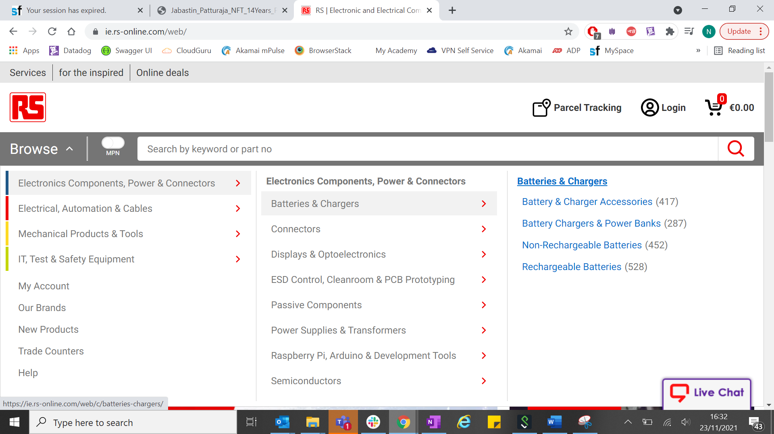

1. Access **Category 2** Page by pasting the URL as it is given in the description above. **(step 3)**
2. Access **Category 3** Page by pasting the URL as it is given in the description above. **(step 4)**
3. Select a random product from your **Category 3** page as seen in the example below:

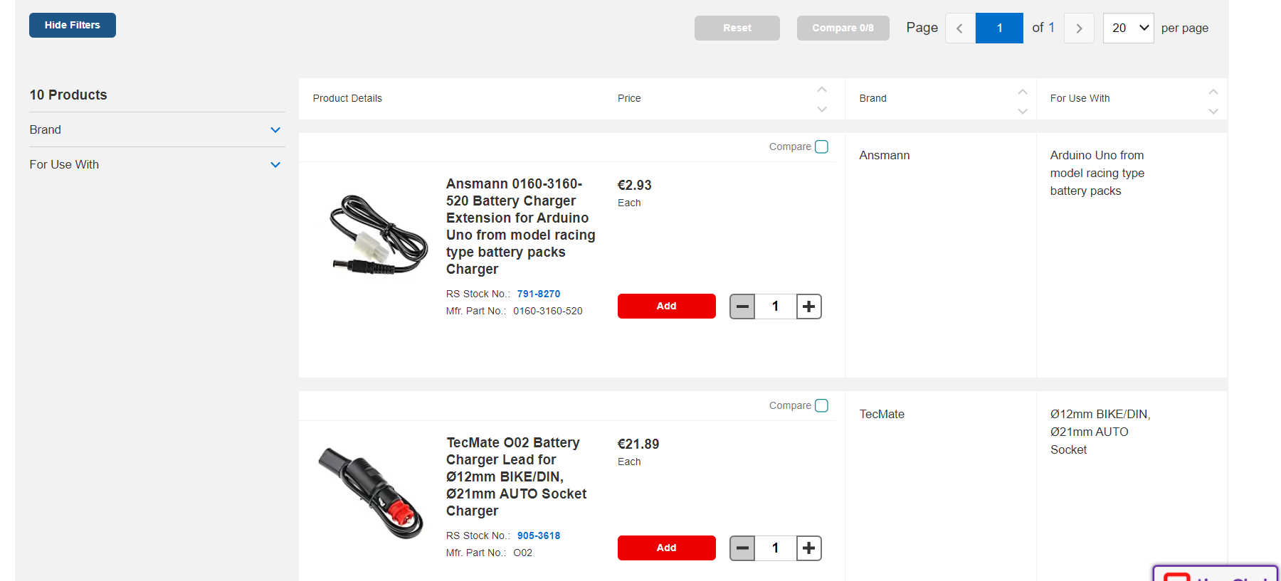

1. You should be viewing the product which you selected in the previous step. Now, click on the **‘Add to basket’** button to add the product to your basket.

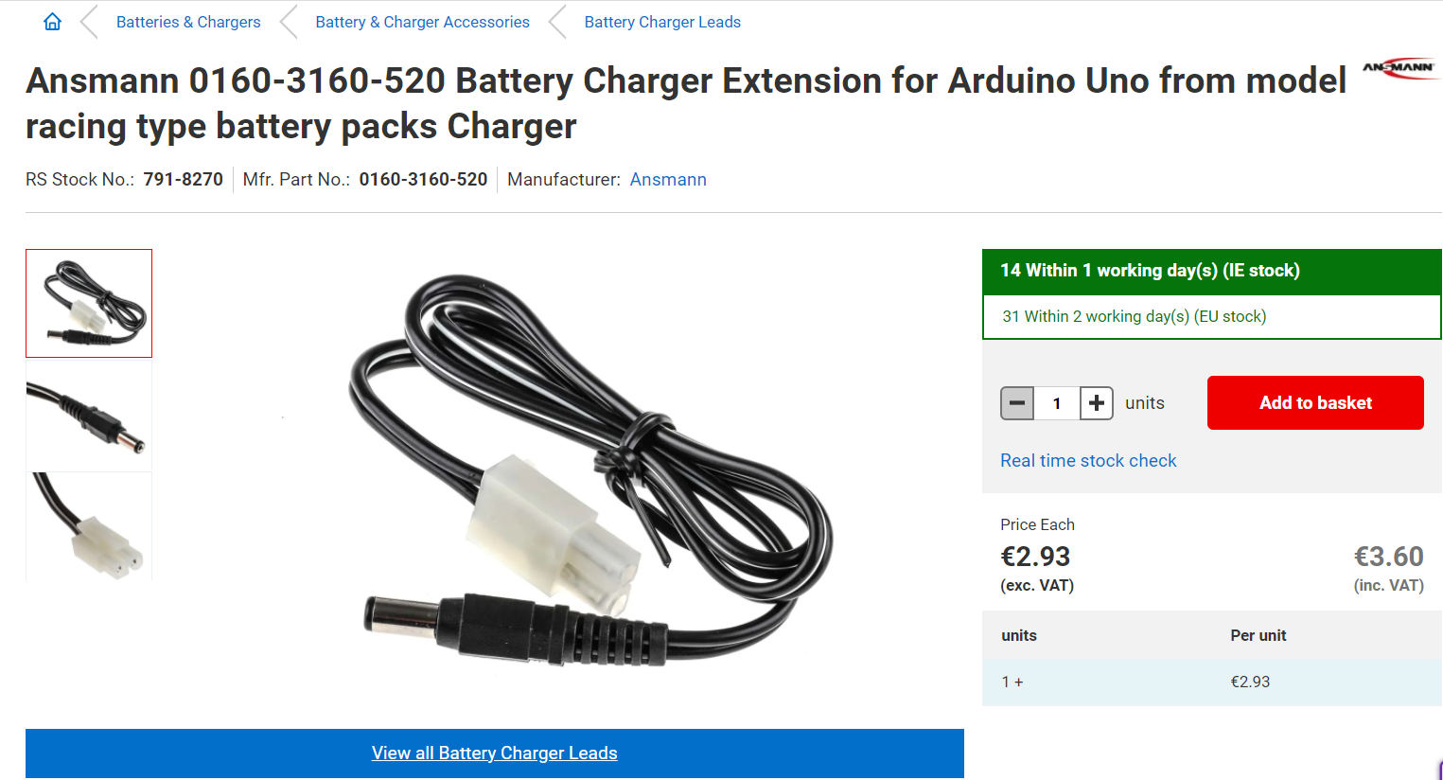

1. Click on View Basket as highlighted on the image below. You will now reach the Basket Page (URL shown above in step 7). This is the end of your user journey.

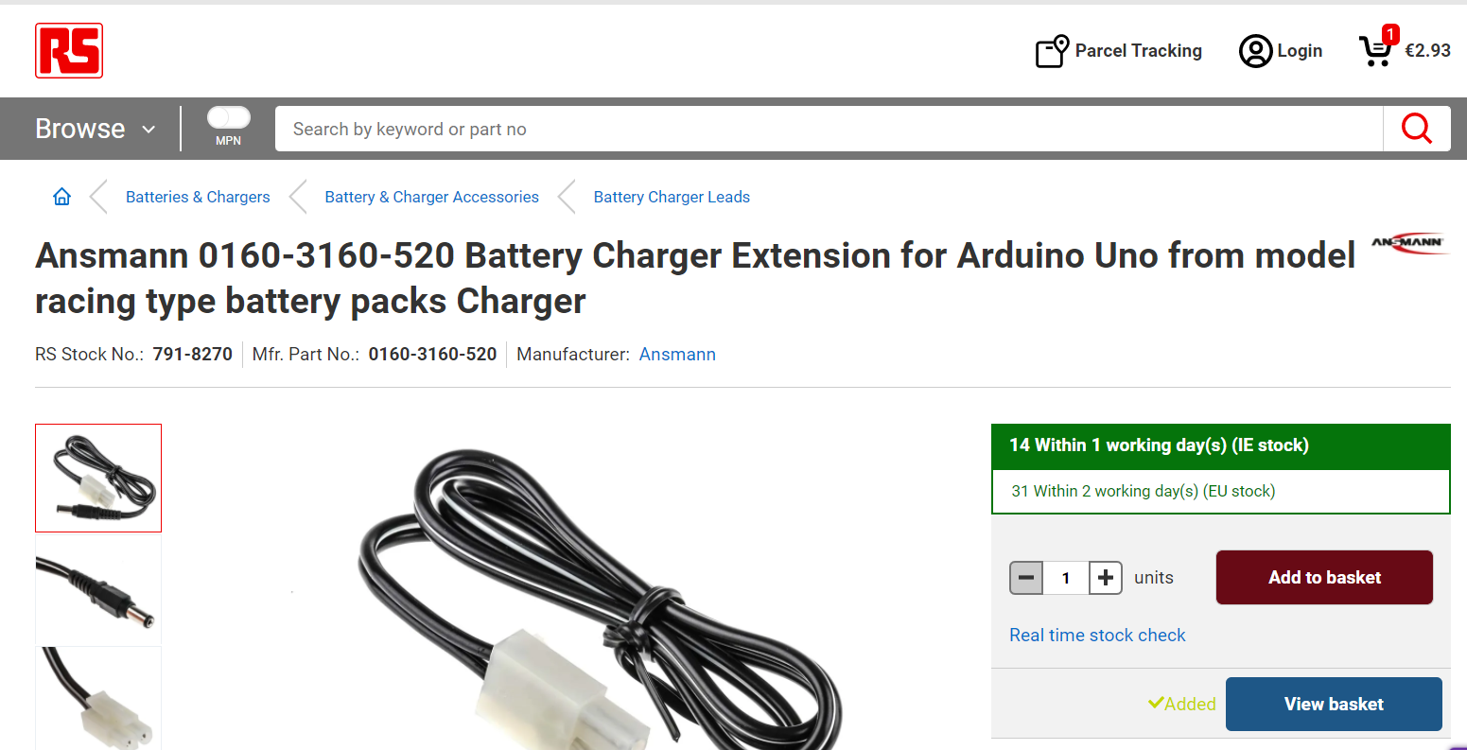

**Parameterising your script:**

Following the recording of your script, please parameterize the category pages using the following .csv file.



In any case that you are not able to access the .csv file, you can create your own data file using the raw data below:

|  |
| --- |
| Category1,Category2,Category3  relays,control-relays,impulse-relays  batteries-chargers,battery-chargers-power-banks,battery-chargers  cables-wires,computer-cable-assemblies,computer-power-cable-assemblies  cables-wires,audio-video-cable,av-cables  switches,foot-switches-accessories,foot-switch-guard-covers  automation-control-gear,process-control,ammeters  lighting,emergency-lighting-safety-lighting,emergency-exit-signs  engineering-materials-industrial-hardware,metal-materials,metal-tubes  batteries-chargers,battery-charger-accessories,battery-contacts  fuses-sockets-circuit-breakers,circuit-protection-circuit-breakers,circuit-trips |